**BRIEF INTRODUCTION:**

Including in my submission, there will be **three .py files** **written in Python 3.6.** They are **Project_Part1.py, Project_Part2_Circle.py and Project_Part2_Ellipse.py.** These three files are corresponding the part1 on the technical assessment, part2 for fitting a circle and part2 for fitting an ellipse. I will talk about how to run these Python 3.6 files in more details later.

In case you have no time to install the relevant software or IDE to run my code, **I have also included 3 PDF files for all my work.** **In both Python files and PDF files**, you will notice there are **comments** next to each line of my code. Those comments will be extremely helpful to understand my code. If there is any confusion, please feel free to contact me and I will explain those in full detail.

In addition, I have also attached **three short video demonstrations** for those Python files **including my personal narration.**

**INSTRUCTION FOR RUNNING THE CODE:**

1. **Install the ANACONDA** at following link and be sure to **select Python 3.7 version**. The 3.7 version is compatible with my code in Python 3.6.

<https://www.anaconda.com/download/#windows>

1. **Open the ANACONDA Navigator** you will see the window like this:

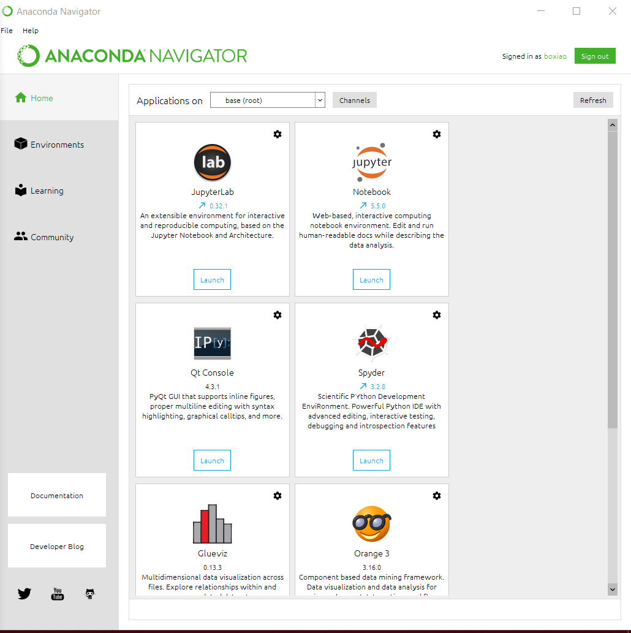

1. Go the **top right corner** and **sign in**.
2. After you sign in with your account, we are going to install opencv.

- Go the left-hand side and **click ‘Environments’**

- Select ‘**Not installed**’

- **Type opencv, search and install**

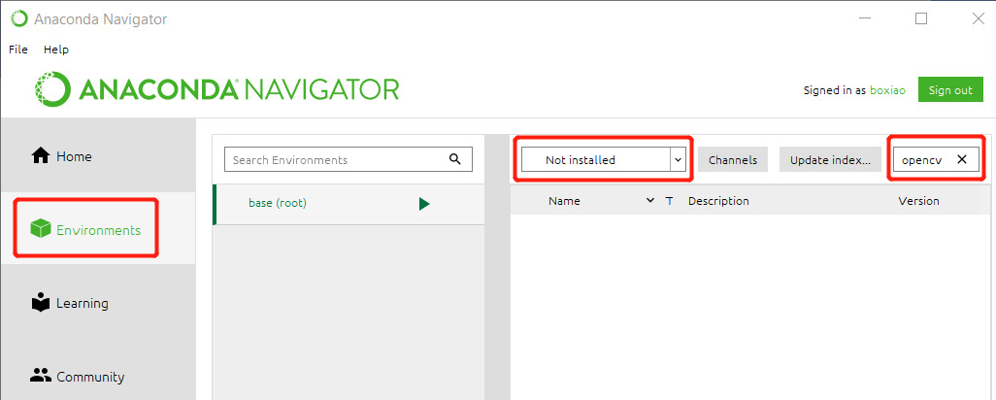

1. Once the installation is finished, you are expected to see this:

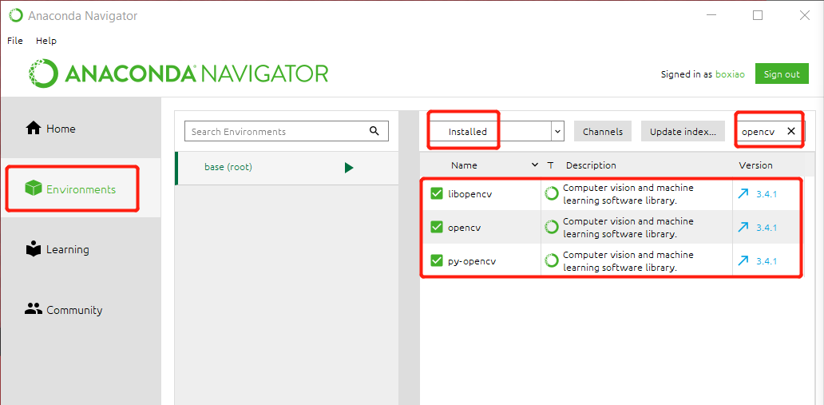

1. Then go back to the ANACONDA navigator page by clicking ‘Home’ and launch Spyder:

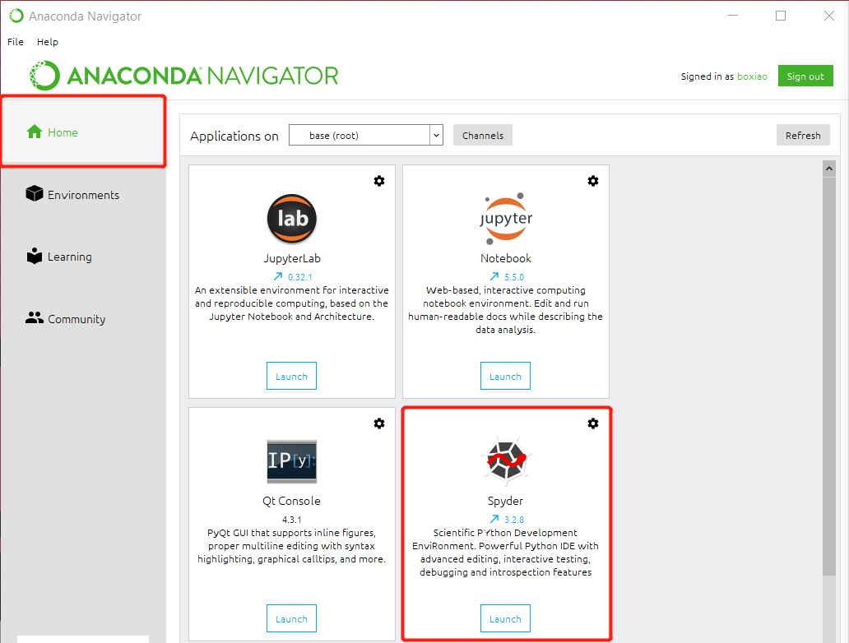

1. Open the .py files I submited with Spyder:

- Click the **Green Arrow** that I use a red square to highlight and it will **run the program**. After you hit the green arrow, you are expected to see **a new window showing 40 by 40 dots**. Then, you can perform certain tasks depending which file you are running.

**- If you wish to close the window or restarting the current program, please right click ‘Console 1/A’ and select ‘Restart Kernel’. Wait for several seconds, the window will disappear and the Python console shows In[1]:.**

